Tab 1
LCD Peel Instructions for Converting into Spatial Light Modulator

For a visual tutorial, the following link below is a video demonstration of this process: https://drive.google.com/file/d/1fwUAABF2eI8yTFx8HDxurPF_IqHwtI44/view?usp=drive_link

STEP 1: Obtain LCD Image 1
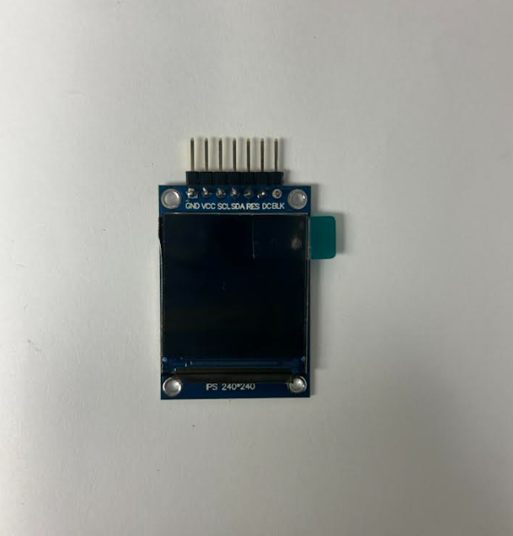
This tutorial utilizes the small LCD display as shown in Image 1. The specs of the display are listed below:
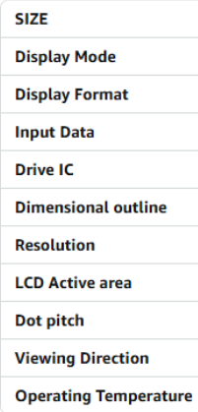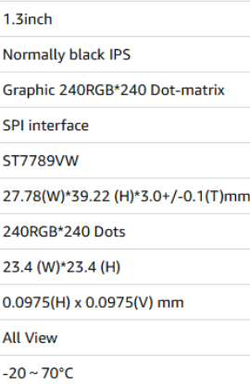

- It is recommended to solder the pins on the display before beginning the peeling process if pins are not attached already.

- Note that displays may vary between manufacturers but the process remains relatively the same.

STEP 2: Begin the Peeling Process Image 2
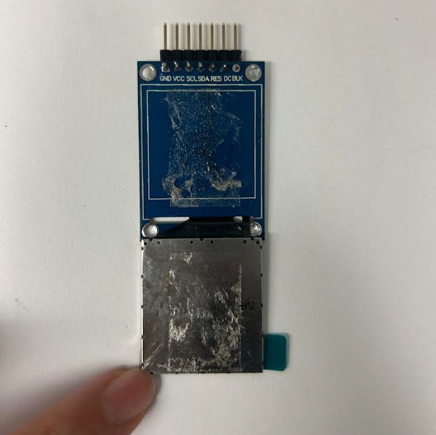
The process starts by peeling back the metal plate from the backing of the display. Some tools required for this are a razor blade and a heat gun if necessary. Start by inserting the blade underneath the metal bottom of the display between the backing and itself. Slide the razor along the edges and through the middle to pry the display off its backing. A heat gun can help soften the adhesive, however, be cautious not to damage the screen in the process. Once the plate is removed off the backing it should look like the display in Image 2.
- Be sure not to damage the wiring attached to the display at the bottom
- If desired, cover the adhesive on the back with masking tape to avoid sticking of the other layers

STEP 3: Remove Metal Backing Image 3
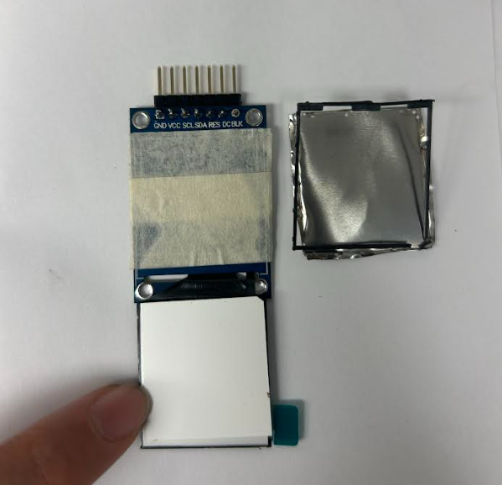
The next step is to remove the metal backing. A razor and thin tweezers/scissors are recommended for this step. First, use a razor to insert in between the screen and metal plate, slightly peeling back the metal. Next, use tweezers to continue prying the metal from around the edge of the display, moving around the perimeter of the screen. After edges have been pried off, the backplate should come off effortlessly. Results are shown in Image 3 to the right.

STEP 4: Remove all Loose Sheets
Image 4 (White opaque sheet)
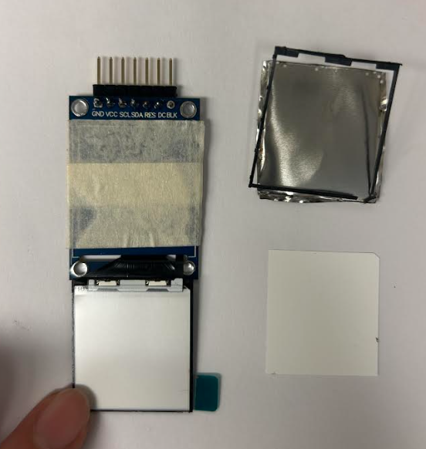
Images 4-6 depict all loose sheets that will fall out once the metal plate is removed. At the bottom of all these sheets should be the backlight of the display which can be seen in Step 5.

Image 5 (Clear plastic sheet)
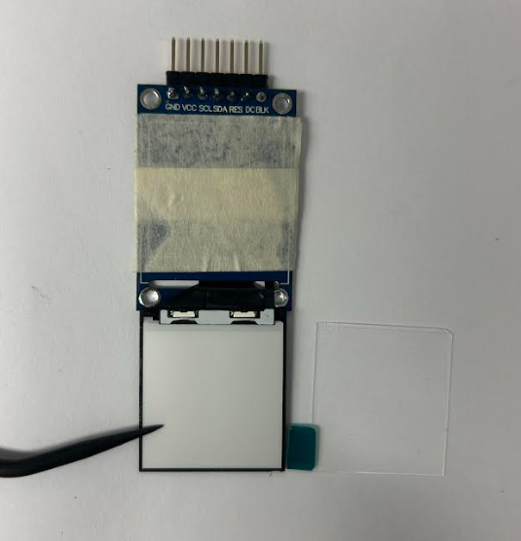

Image 6 (Clear thin plastic sheet)
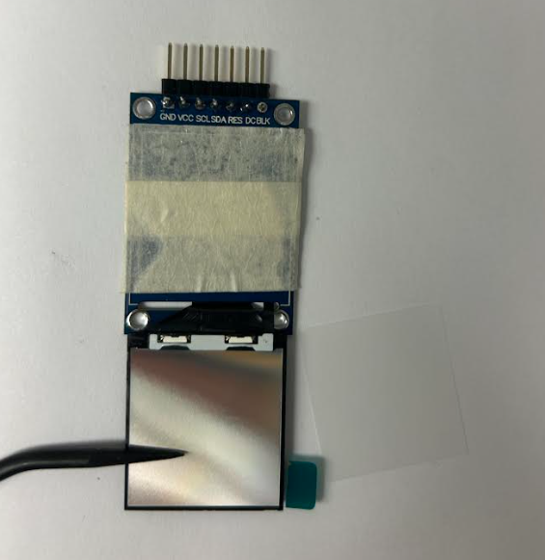

Image 7 (Reflective sheet)
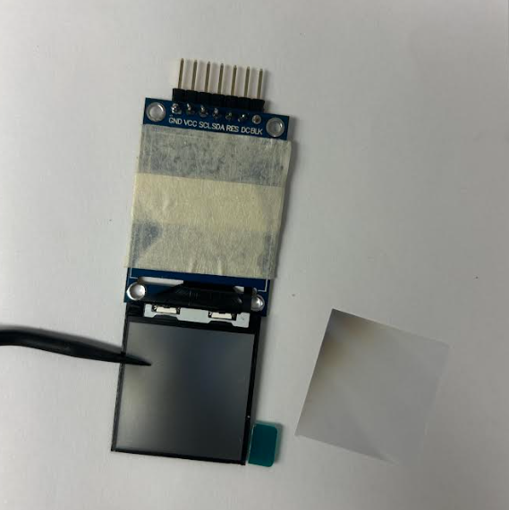

STEP 5: Remove Backlight Image 8
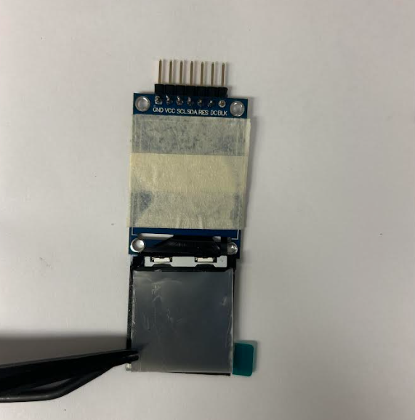
After removing the loose sheets, the next layer is the backlight of the display. This needs to be removed. This layer is attached through a small cable which can be seen in Image 9. This cable can be snipped which should disconnect the backlight and allow it to easily be peeled off. Results are shown in Image 10 below.

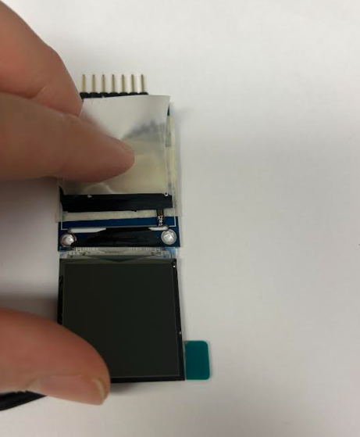

Image 9
Image 10
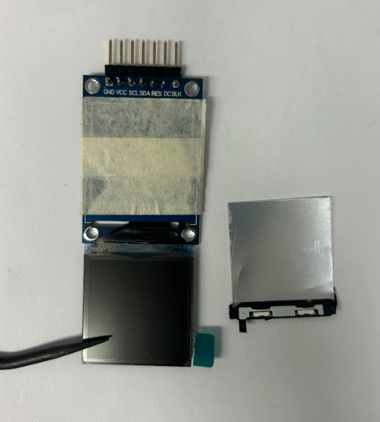

STEP 6: Remove the Back Polarizer of the Image 11
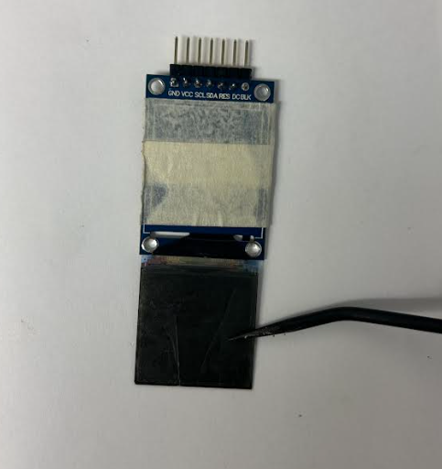
LCD

The final layer to be removed is the polarizer on the back of the LCD. There should be a polarizer on both the front of the display and the back. Do not remove the front. The process for removing this layer is tedious, requiring a razor to slowly peel back the screen. This step will be the hardest as the LCD is thin and delicate. Be sure not to apply too much pressure on the screen or else it will crack. A heat gun may make the process easier since the layer is held in place with an adhesive, however, this may damage the crystals within the LCD resulting in a broken screen.
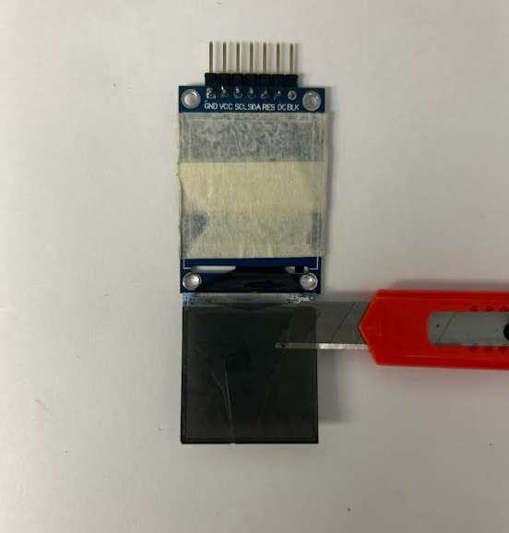
Image 12
The process of peeling can be seen in Image 12 while the final peeled display is shown in Image 13. Remember to be cautious with this final step. Backup displays are recommended for this process as it is a bit tricky to remove the final layer.

This final step concludes the process of the LCD peeling instructions. For a visual tutorial of the process, please see the link at the beginning of this document.

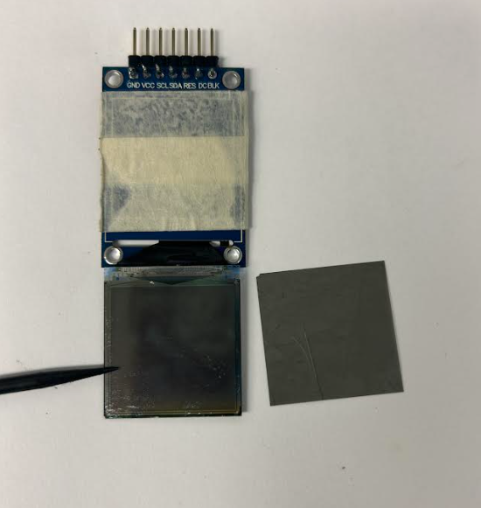
Image 13

